Lab: 3

###### Name_____AKASH SHARMA_____ Roll No. ___35__________Group No.______1______

###### Date of Performance _______________ Faculty’s Signature_________________________

**Laboratory Objective:** To implement file handling commands of Linux

**Learning Outcomes:**

1. The status of user currently logged in.
2. Lost and change permission of files
3. Back up of home directory



* 1. **Introductory Commands**
     1. Write the command to know who has currently logged into the system, but split the command in 3 lines and execute.
  2. 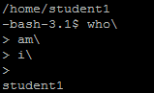
  3. **Files and Directories:**
     1. Write the command to see how much space has been occupied by your home directory
     2. 
     3. Write the command to redirect the manual of ls command into file “lshelp” and display its content page-wise on the screen.
     4. 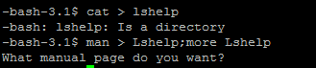
     5. Write the command to display only last 3 lines and first 3 lines of “lshelp”.
     6. 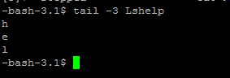
     7. Write the command to find the nature of the file “lshelp”. Also show the output if the argument is a directory.
     8. 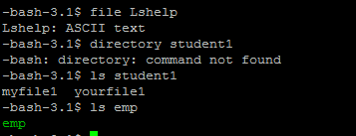
     9. Write the command to list all the files by the name SAMPLE, irrespective of the case.
     10. 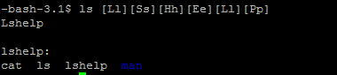
     11. Write the command to list all files starting with lowercase letters.
     12. 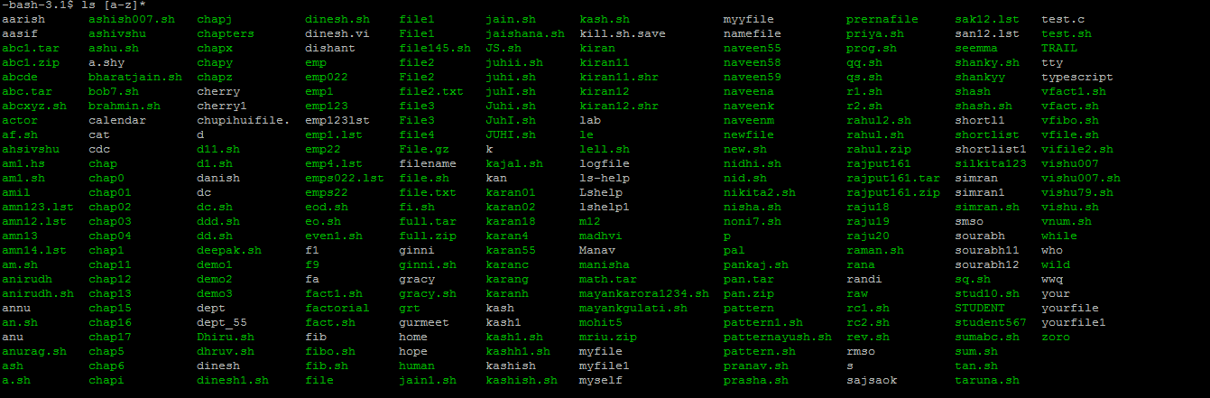
     13. Write the command to change the permission of “myfile” to 555. After this write the command to remove the file “myfile” and explain the output.
  4. **General Utilities:**
     1. Write the command to display the status of active processes and explain the output.
     2. 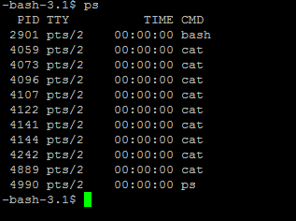
     3. Write the command to create the backup of your home directory into “backup” such that the execution takes place in background.
     4. Write the command to kill the above process forcibly and remove the directory “backup”.